Opening Block Processing Design

Overview

Current processing
After BC gets the product state change request for a class, BC will create one preOpen/opening command for each series in the class and these commands are eventually joining the other commands and sitting in the command processor queue for each class and are handled by 1 single thread for this class. This process uses a lot of processing power during the opening and potentially delays the other commands for this class in the same queue.

New requirement
To block the preOpen/opening events and sequentially/parallel process the preOpen/Opening events within the block. Processing includes EOP calculation and opening if product is openable. By doing so, we will reduce #ofCommands sitting in the commandQueue and system time to acquire the class level lock. The EOP messages will be gathered and sent out as a block. Parallel processing will hopefully shorten the overall opening processing time.

Implementation

Collecting pre-open/opening product state change events
- New behavior vs. old behavior
Old behavior:
- Product state change event is sent to state change listener per series.
- Product state change events are sent to external product state publisher per class if it is class level change and series by series if it is non-class level change. Class level block publishing is achieved by using the inner class ProductStateCollector in ProductStateChangeByClassCommand.
New behavior:
- Product state change events will be collected within a transaction and sent to the state change listener and external product state publisher per class.

- A new TransactionListener ProductStateCollector is introduced to collect all the product state events within a transaction.
- Once the transaction is commited, ProductStateCollector will send the product state change events to external product state publisher AND to the internal state change listeners per trading class.
- The inner class ProductStateCollector in the existing ProductStateChangeByClassCommand becomes redundant after the change, therefore is removed.
- Classes changed:
- Repackaged com.cboe.server.event.ObjectCollector to com.cboe.server.util.ObjectCollector.
- Removed following unused classes:
/vobs/dte/server/Java/common/com/cboe/server/events/BookDepthConsumerHomeTransactionCollectedImpl.java
/vobs/dte/server/Java/common/com/cboe/server/events/BookDepthPublisherTransactionCollected.java
/vobs/dte/server/Java/common/com/cboe/server/events/CurrentMarketConsumerHomeLocalTransactionCollectedImpl.java
/vobs/dte/server/Java/common/com/cboe/server/events/CurrentMarketConsumerHomeNoPubTransactionCollectedImpl.java
/vobs/dte/server/Java/common/com/cboe/server/events/CurrentMarketConsumerHomeTransactionCollectedImpl.java
/vobs/dte/server/Java/common/com/cboe/server/events/CurrentMarketPublisherTransactionCollected.java
/vobs/dte/server/Java/common/com/cboe/server/events/PublisherTransactionCollectedBase.java
/vobs/dte/server/Java/common/com/cboe/server/events/RecapConsumerHomeTransactionCollectedImpl.java
/vobs/dte/server/Java/common/com/cboe/server/events/RecapPublisherTransactionCollected.java
/vobs/dte/server/Java/common/com/cboe/server/events/TickerConsumerHomeLocalTransactionCollectedImpl.java
/vobs/dte/server/Java/common/com/cboe/server/events/TickerPublisherTransactionCollected.java
/vobs/dte/server/Java/common/com/cboe/server/internalEvents/CurrentMarketStateChangeConsumerHomeNoPubTransactionCollectedImpl.java
/vobs/dte/server/Java/common/com/cboe/server/internalEvents/CurrentMarketStateChangeConsumerHomeTransactionCollectedImpl.java
/vobs/dte/server/Java/common/com/cboe/server/internalEvents/CurrentMarketStateChangePublisherTransactionCollected.java
- Added/changed the following classes:
/vobs/dte/server/Java/impls/com/cboe/internalBusinessServices/productStateService/ProductStateCollector.java
/vobs/dte/server/Java/impls/com/cboe/internalBusinessServices/productStateService/ProductStateServiceLocalImpl.java
/vobs/dte/server/Java/interfaces/com/cboe/internalBusinessServices/StateChangeListener.java
/vobs/dte/server/Java/impls/com/cboe/businessServices/brokerService/BrokerServiceImpl.java
/vobs/dte/server/Java/common/com/cboe/server/events
/vobs/dte/server/Java/common/com/cboe/server/events/BookDepthObjectCollector.java
/vobs/dte/server/Java/common/com/cboe/server/events/BookDepthPublisherBOSessionCollected.java
/vobs/dte/server/Java/common/com/cboe/server/events/CurrentMarketObjectCollector.java
/vobs/dte/server/Java/common/com/cboe/server/events/CurrentMarketPublisherBOSessionCollected.java
/vobs/dte/server/Java/common/com/cboe/server/events/EventPublisherObjectCollector.java
/vobs/dte/server/Java/common/com/cboe/server/events/ExpectedOpeningPriceObjectCollector.java
/vobs/dte/server/Java/common/com/cboe/server/events/PublisherBOSessionCollectedBase.java
/vobs/dte/server/Java/common/com/cboe/server/events/RecapObjectCollector.java
/vobs/dte/server/Java/common/com/cboe/server/events/RecapPublisherBOSessionCollected.java
/vobs/dte/server/Java/common/com/cboe/server/events/TickerObjectCollector.java
/vobs/dte/server/Java/common/com/cboe/server/events/TickerPublisherBOSessionCollected.java
/vobs/dte/server/Java/common/com/cboe/server/internalEvents
/vobs/dte/server/Java/common/com/cboe/server/internalEvents/CurrentMarketStateChangeObjectCollector.java /vobs/dte/server/Java/common/com/cboe/server/internalEvents/CurrentMarketStateChangePublisherBOSessionCollected.java
/vobs/dte/server/Java/common/com/cboe/server/util
/vobs/dte/server/Java/common/com/cboe/server/util/ObjectCollector.java

Flow of processing of product state changes by class and blocking
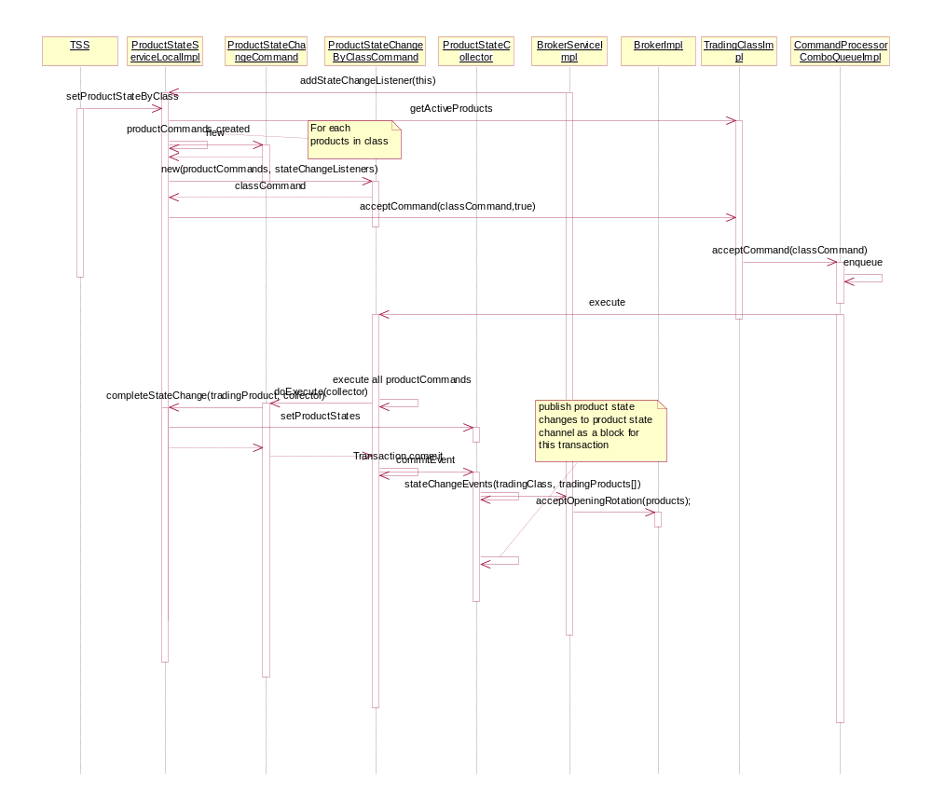

Interface change -- StateChangeListener
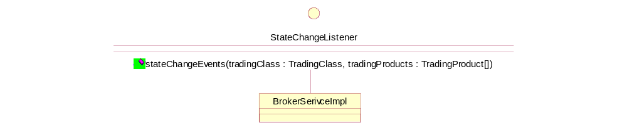

TradingClass Block Command Processing Class design
- There is a need for refactoring to improve the design of existing block commands so more code could be reusable for any block command processing task.

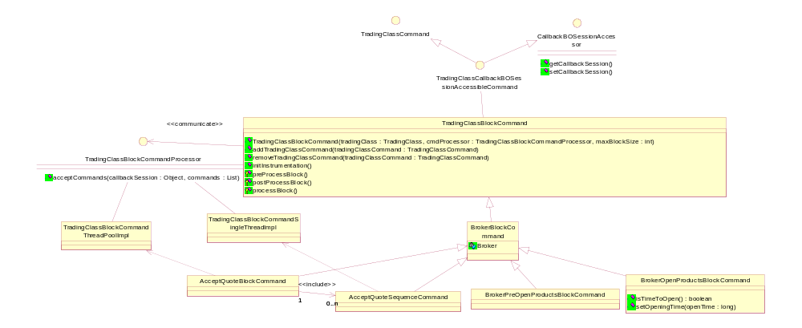
- TradingClassBlockCommand is the base class for a block of TradingClassCommands that the TradingClass deals with. It contains a list of trading class commands. It manages the transaction that this list of commands runs in and processing of these commands. Any TradingClassCommands that need to manage a block of TradingClassCommands could extend this. Please note that as worker threads in thread pool does not join the transaction session, this framework does not support the block of commands that do not start the transaction on its own. It leaves for the future improvement and testing.
- AcceptQuoteBlockCommand and AcceptQuoteSequenceCommand are refactored to use this new framework as shown in the above class diagram.
- Each type of block commands are configurable in TradingClassBlockCommand.xml and has the following properties:
- MaxBlockSize – max block size for the block command.
- parallelProcessing (true/false) - if true, TradingClassBlockCommandThreadPoolImpl is created for this type of block command and a thread pool will parallel process the commands within the class level lock. Otherwise, TradingClassBlockCommandSingleThreadImpl is used and commands in the block is processed sequentially.
NOTE: When processing block command for strategy products, TradingClassBlockCommandSingleThreadImpl is always used to process the commands in the block sequentially.
- blockTransaction (true/false) – if true, transaction will be started at the execution.
- enableMethodInstrumentation (true/false) – if true, command execution time will be instrumented.
- PrivateMethodInstrumentation (true/false) – if true, the method instrumentation data will not be published through Instrumentation channel to SystemHealthMonitor gui and still be available to monitor through *MI.log in ${RUN_DIR}/log on the local disk if the following switches are turned on.
-DInstrumentationService.StartDefaultFileMonitors=true
-DInstrumentationService.FileOutput.MI.OutputPrivate=true
- Classes that are changed.
a. Removed the following classes:

/vobs/dte/server/Java/impls/com/cboe/businessServices/brokerService/threadingUtil
/vobs/dte/server/Java/interfaces/com/cboe/interfaces/businessServices/threadingUtil
/vobs/dte/server/Java/impls/com/cboe/businessServices/brokerService/BrokerQuoteBlockCommandProcessorHomeBaseImpl.java
/vobs/dte/server/Java/impls/com/cboe/businessServices/brokerService BrokerCommandSingleThreadHomeImpl.java
/vobs/dte/server/Java/impls/com/cboe/businessServices/brokerService BrokerCommandSingleThreadNoTransactionHomeImpl.java
/vobs/dte/server/Java/impls/com/cboe/businessServices/brokerService BrokerCommandThreadPoolHomeImpl.java
/vobs/dte/server/Java/impls/com/cboe/businessServices/brokerService BrokerCommandSingleThreadNoTransactionImpl.java
/vobs/dte/server/Java/interfaces/com/cboe/interfaces/businessServices/threadingUtil BrokerQuoteBlockCommandProcessor.java
/vobs/dte/server/Java/interfaces/com/cboe/interfaces/businessServices/threadingUtil BrokerQuoteBlockCommandProcessorHome.java

b. Created a concurrent package under server common util and moved/renamed the following classes to this package.

com.cboe.businessServices.brokerService.threadingUtil.ReentrantFIFOSemaphore --> com.cboe.server.util.concurrent.ReentrantFIFOSemaphore
com.cboe.businessServices.brokerService.threadingUtil.Semaphore --> com.cboe.server.util.concurrent.CountDownLatch

c. Created a commandProcessing package under server common and moved the following classes in com.cboe.internalBusinessServices.productStateService to this package.

com.cboe.internalBusinessServices.productStateService.CommandProcessor --> com.cboe.server.commandProcessing.CommandProcessor
com.cboe.internalBusinessServices.productStateService.CommandProcessorComboQueueHomeImpl --> com.cboe.server.commandProcessing.CommandProcessorComboQueueHomeImpl
com.cboe.internalBusinessServices.productStateService.CommandProcessorComboQueueImpl --> com.cboe.server.commandProcessing.CommandProcessorComboQueueImpl
com.cboe.internalBusinessServices.productStateService.CommandProcessorHome --> com.cboe.server.commandProcessing.CommandProcessorHome
com.cboe.internalBusinessServices.productStateService.CommandProcessorHomeImpl --> com.cboe.server.commandProcessing.CommandProcessorHomeImpl
com.cboe.internalBusinessServices.productStateService.CommandProcessorImpl --> com.cboe.server.commandProcessing.CommandProcessorImpl
com.cboe.internalBusinessServices.productStateService.CommandProcessorQueuelessHomeImpl --> com.cboe.server.commandProcessing.CommandProcessorQueuelessHomeImpl
com.cboe.internalBusinessServices.productStateService.CommandProcessorQueuelessImpl --> com.cboe.server.commandProcessing.CommandProcessorQueuelessImpl
com.cboe.internalBusinessServices.productStateService.CommandProcessorTransientHomeImpl --> com.cboe.server.commandProcessing.CommandProcessorTransientHomeImpl
com.cboe.businessServices.brokerService.threadingUtil.BrokerCommandProcessor -->
com.cboe.server.commandProcessing.TradingClassCommandProcessor
com.cboe.businessServices.brokerService.threadingUtil.BrokerCommandQueue -->
com.cboe.server.commandProcessing.TradingClassCommandQueue
com.cboe.businessServices.brokerService.threadingUtil.BrokerCommandSemaphorePair -->
com.cboe.server.commandProcessing.TradingClassCommandCountDownLatchPair
d. Added/Changed the following classes:
/vobs/dte/server/Java/common/com/cboe/server/commandProcessing/CallbackBOSessionAccessor.java
/vobs/dte/server/Java/common/com/cboe/server/commandProcessing/TradingClassBlockCommand.java
/vobs/dte/server/Java/common/com/cboe/server/commandProcessing/TradingClassBlockCommandHomeImpl.java
/vobs/dte/server/Java/common/com/cboe/server/commandProcessing/TradingClassBlockCommandSingleThreadImpl.java
/vobs/dte/server/Java/common/com/cboe/server/commandProcessing/TradingClassBlockCommandThreadPoolImpl.java
/vobs/dte/server/Java/common/com/cboe/server/commandProcessing/TradingClassCallbackBOSessionAccessibleCommand.java
/vobs/dte/server/Java/common/com/cboe/server/commandProcessing/TradingClassCommandCountDownLatchPair.java
/vobs/dte/server/Java/common/com/cboe/server/commandProcessing/TradingClassCommandQueue.java
/vobs/dte/server/Java/common/com/cboe/server/commandProcessing/TradingClassCommandQueueProcessor.java
/vobs/dte/server/Java/common/com/cboe/server/util/concurrent
/vobs/dte/server/Java/common/com/cboe/server/util/concurrent/CountDownLatch.java
/vobs/dte/server/Java/impls/com/cboe/businessServices/brokerService
/vobs/dte/server/Java/impls/com/cboe/businessServices/brokerService/AcceptQuoteBlockCommand.java
/vobs/dte/server/Java/impls/com/cboe/businessServices/brokerService/AcceptQuoteBlockCommandHomeImpl.java
/vobs/dte/server/Java/impls/com/cboe/businessServices/brokerService/AcceptQuoteSequenceCommand.java
/vobs/dte/server/Java/impls/com/cboe/businessServices/brokerService/AcceptQuoteSequenceCommandHomeImpl.java
/vobs/dte/server/Java/impls/com/cboe/businessServices/brokerService/BrokerBlockCommand.java
/vobs/dte/server/Java/impls/com/cboe/businessServices/brokerService/BrokerCommand.java
/vobs/dte/server/Java/impls/com/cboe/businessServices/brokerService/BrokerImpl.java
/vobs/dte/server/Java/impls/com/cboe/businessServices/brokerService/BrokerOpenProductCommand.java
/vobs/dte/server/Java/impls/com/cboe/businessServices/brokerService/BrokerOpenProductsBlockCommand.java
/vobs/dte/server/Java/impls/com/cboe/businessServices/brokerService/BrokerOpenProductsBlockCommandHomeImpl.java
/vobs/dte/server/Java/impls/com/cboe/businessServices/brokerService/BrokerPreOpenProductsBlockCommand.java
/vobs/dte/server/Java/impls/com/cboe/businessServices/brokerService/BrokerPreOpenProductsBlockCommandHomeImpl.java
/vobs/dte/server/Java/interfaces/com/cboe/interfaces/businessServices
/vobs/dte/server/Java/interfaces/com/cboe/interfaces/businessServices/AcceptQuoteBlockCommandHome.java
/vobs/dte/server/Java/interfaces/com/cboe/interfaces/businessServices/AcceptQuoteSequenceCommandHome.java
/vobs/dte/server/Java/interfaces/com/cboe/interfaces/businessServices/BrokerOpenProductsBlockCommandHome.java
/vobs/dte/server/Java/interfaces/com/cboe/interfaces/businessServices/BrokerPreOpenProductsBlockCommandHome.java
/vobs/dte/server/Java/interfaces/com/cboe/interfaces/businessServices/TradingClassBlockCommandHome.java
/vobs/dte/server/Java/interfaces/com/cboe/interfaces/businessServices/TradingClassBlockCommandProcessor.java

Flow of processing Pre-Open/Opening block command when parallelProcessing flag is set to false
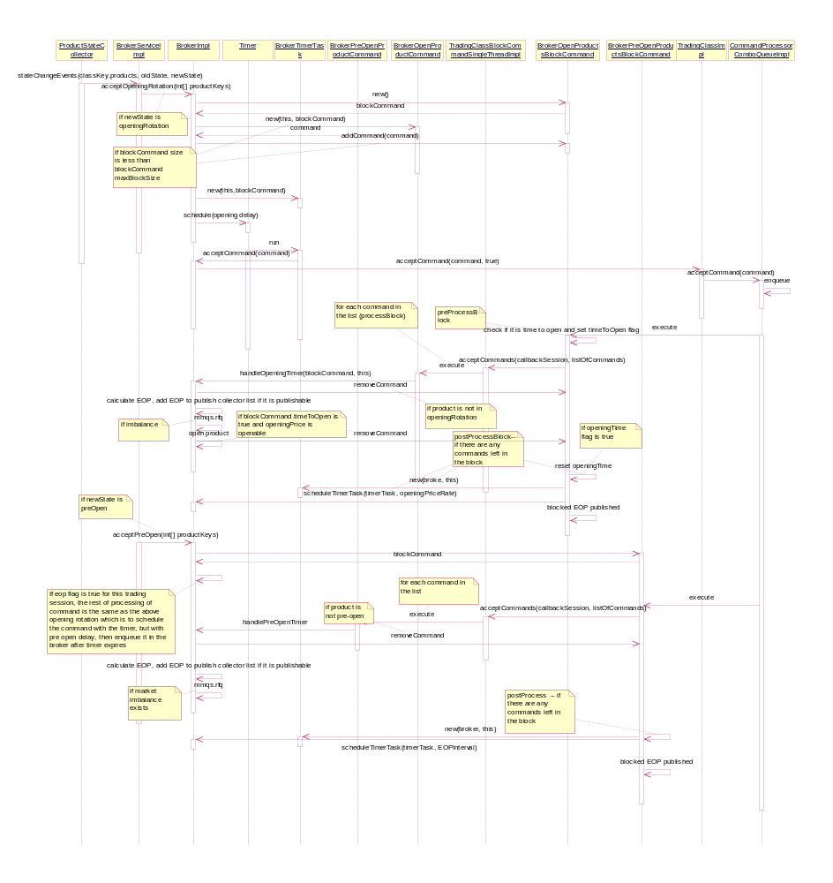

Flow of processing blocked opening events when parallelProcessing flag is set to true

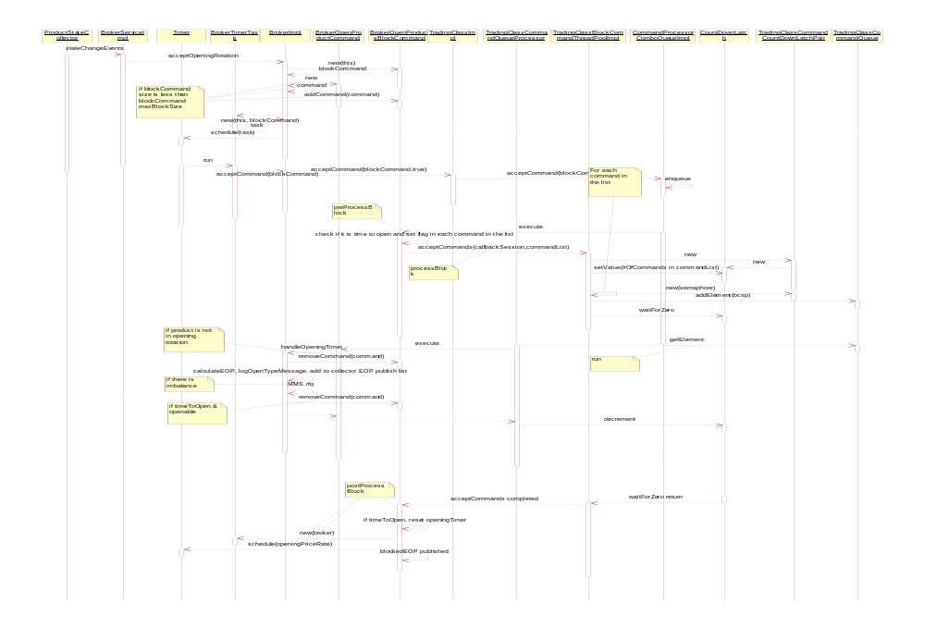

Scripts(2)
- None

Database(.5)
- None

SetContext(.125)
- -DprefixNumberOfQuoteThreadPoolThreads → -DprefixTradingClassBlockCommandThreadPoolThreadCount

XML/DTD(.5)
- TradingClassBlockCommand.dtd
- TradingClassBlockCommand.xml
- CFETradeServer.xml
- COFTradeServer.xml
- EquityTradeServer.xml
- ExtTradeServer.xml
- HybridTradeServer.xml
- TradeServer.xml
- XML re-genration required

Homes/Services(4)
- AcceptQuoteBlockCommandHome
- AcceptQuoteSequenceCommandHome
- BrokerPreOpenProductsBlockCommandHome
- BrokerOpenProductsBlockCommandHome
Removed:
- BrokerQuoteBlockCommandProcessorHome

ImplPlan(.5)
- See project impl plan

PerformanceTestingProcedure(1)
- See Opening Block Processing Perf Testing Plan.doc

TestingProcedure(1)
- See Opening Block Processing Test Plan.doc

OperatorProcedure(.5)
- None

Fallback/Failover

See regular fallback/failover procedure.

